

Annual Work Programme & Budget

Administrative System

dministrative Systemtem Project

User Manual

**Table of Contents**

INTRODUCTION ……………………………………………………………………………………………………………………………….5

OBJECTIVE ……………………………………………………………………………………………………………………………………….5

SYSTEM REQUIREMENTS …………………………………………………………………………………………………………………5

ACCESSING THE PORTAL……………………………………………………………..……………………………………………………5

Useful Tips ……………………………………..……..………………………………………….…………………………………....………6-9

**STEP 1**………………………………………………………………………………………..……………………………………………………..10

Concession Situation as at 1st January……………………………………………….…………………………………....……….10

Geophysical Activities on Quarterly Basis…………………………………………………………………………………………..11

Acquisition…………………………………………………………………………………………………..………………….…………………11

Processing……………………………………………………………………………………………….…………………………..…………….12

Drilling Operations…………………………………………………………………………………….……………………………..………..13

**STEP 2**………………………………………………………………………………………..……………………………………………………….14

Initial Well Completion Jobs On Quarterly Basis………………………………………….……………………………..……... 14

Workovers & Recompletion Jobs On Quarterly Basis………………………………………………………………….…..…..15

Field Development Plan……………………………………………………………………………..……………………………………….15

Oil/Condensate Production Activities……..…………………………………………….…………………………….……………..16

Actual Year Monthly Production……..………………………………………….……………………………………….……………..16

Proposed Year Monthly Production…………………………………………………………………………………………..………..17

Five Year Production Forecast……………………………………………………………………………………………………………..17

Unitization……………………………………………………………………………………………………………………………………..…...18

Gas production activities……………………………………………………………………………………………………………….…….19

Domestic Gas Supply Obligation & Distribution……………………………………………………………………………………19

Reserves updates (oil & condensate) (mmbl)………………………………………………………………….…………………..20

Status of Reserves………………………………………………………………………………………….……………………………………20

Concession Reserves for preceding year (as at 1st January)………………………..………………………….20

Concession Reserves (as at 1st January)…………………………………………………………….…………………..20

Five (5) Year Reserves Projection……………………………………………………………………………….…………..21

Company Annual Production…………………………………………………………………………………………..……..22

Reserves Addition…………………………………………………………………………………………………………………..22

Reserves Decline…………………………………………………………………………………………..………………………..22

Five-Year Trend for Concession Reserve Replacement Ratio…………………………………………………..22

STEP 3 ……………………………………………………………………………………………………………………………..…………………23

Budget performance……………………………………………………………………………………………………………….…………..23

Exploratory activities………………………………………………..…………………………………………………….…………………..23

Development drilling activities…………………………………..………………………………………………………………..……..24

Facilities development project…………………………………..…………………………………………………………………..…..24

Production cost…………………………………………………………..…………………………………….………………………………..24

Budget proposal in naira and dollar component…...24

CAPEX & OPEX Items………………………………………………………….…………….……………………………………….………..25

Oil And Gas Facility Maintenance……………………………………….…………….……………………………………….………..26

Major Projects And Upgrades……………………………………………….…………………….………………………………….…..26

New Technology and Conformity Assessment……………………………………………………………………………... …..27

Facilities Project Performance…………………………………………..………………………………………………………..… …..27

**STEP 4**

NIGERIA CONTENT……………………………………………………………………………………………………………………………..28

Staff Disposition - Training for Nigerians……………………………………………………………..……………………………..28

Upload Succession Plan…………………………………………………………………………………….………………………………..28

Strategic Plans On Company Basis……………………………………………………………………………………………………..29

**STEP 5**

HSE………………………………………………………………………………………………………………………………………….………..30

Technical Safety Control Studies……………………………………………………………..………………………………………..30

Inspection and Maintenance……………………………………………………………………………..……………………………..31

Asset Register Template – (Prescriptive Equipment Inspection Strategy) ………….……………………………..31

Asset Register Template – (RBI Equipment Inspection Strategy) ……………………….……………………………..32

Oil Spill Reporting……………………………………………………………………………………………………………………………..33

Causes of Spill…………………………………………………………………………………………………………….………………..33-34

Accident / Incidence Reporting…………………………………………………………..……………………………………………..34

OSP Registrations…………………………………………………………………………………………………………………..……..…..35

Community Disturbances and Oil Spill Cost………………………………………………………………………….…….……..35

Fatalities / Casualties, Man Overboard, TRI and LTI…………………………………………………………………………...36

Loss Prevention Studies (Designs Safety Control) ………………………………………………………………………….…..36

Environmental Studies……………………………………………………………………………………………………………….……...36

Waste Management……………………………………………………………………………………………………………………..37-38

Produced Water Management…………………………………………………………………………………………………………..38

Environmental Compliance Monitoring……………………………………………………………………………………………...39

Environmental studies Five (5) Year Strategic Plan……………………………..……………………………………………...40

SUSTAINABLE COMMUNITY DEVELOPMENT PROJECT & CSR……………………………………………………………..40

Sustainable Development / Community Project/Program………………..…………………………………...40

Capital Projects………………………………………………………………………………………………………..…………....41

Scholarships……………………………………………………………………………………………………………….……..…..41

Trainings and Skill Acquisition…………………………………………………………….………………………………....42

Pictures for Community Development Projects……….………………………………………………………………….……..42

Appendix A: Terms, Definitions and Acronyms …………………………………………………………………….………….. 43

# **INTRODUCTION**

Annual Work Programme & Budget Administrative System is an online portal for all Exploration and Production companies to provide data accordingly.

The system also allows exploration and production companies to upload attachments and pictures as required.

# **OBJECTIVE**

The objective of this documentation is to provide a step by step guide for all Exploration and Production companies on how upload data on Work Programme Online portal.

# **SYSTEM REQUIREMENTS**

The Annual Work Programme & Budget Administrative portal is accessible from any internet connected device. To have access to the platform/ tool to provide data, the below is required:

1. High speed Internet access
2. Internet browser e.g. Mozilla Firefox browser, Internet Explorer, Chrome Browser.

# **ACCESSING THE PORTAL**

Launch any of the approved web browsers stated above, type the following address into the address bar of the browser or click the link <https://workprogram.nuprc.gov.ng/#_>

# **Useful Tips**

Five (5) Steps / forms are expected to be filled accordingly.

Step 1 must be completed before Step 2, Step 3, Step 4 & Step 5 in a sequential order.

Information on a web page must be completed before navigating to the next page i.e. Information must be provided for all the sections accordingly in Step 1 before navigation to step 2.

Data provided in step 1 and step 2 are on **CONCESSION** basis while **step 3 to Step 5** are on **COMPANY** basis.

**Note**: All fields are mandatory. Input NA for a text field or 0 where value expected is numeric and there are no values to be inputted. Null or blank is not allowed.

**Step A**:

Login with account details provided by DPR.

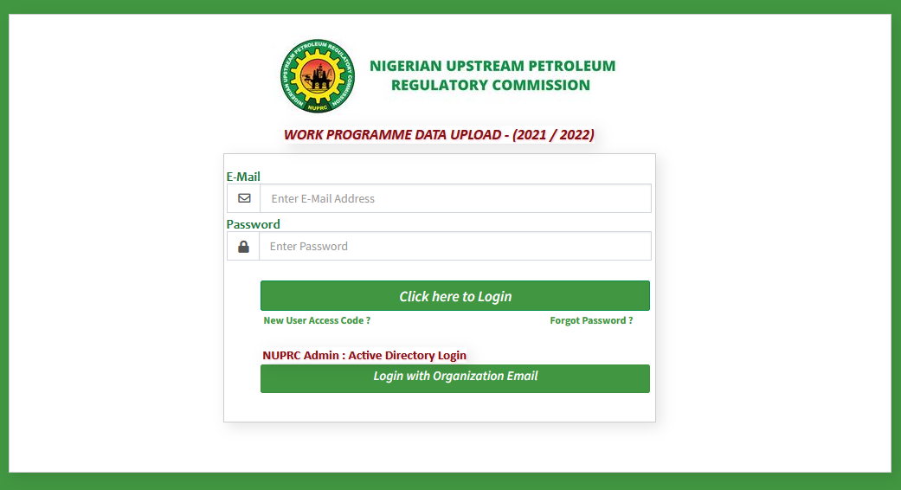

If login is successful the below landing page will be displayed.

As **highlighted** below are useful tips to help complete work programme data submission:

**Left side menu**: This is for navigation purpose.

**Download user guide:** A click on the button will download work programme user guide

**Download Template guide:** A click on the button will download a spread sheet for data collation before it is entered into the portal

**Log out**: A click on the log out button will display the login page.

On the top right, user email is displayed.



**Step B**

In case you forget your password … Click on the “forgot password” on the login page and input email address. Your password will be sent to your mailbox

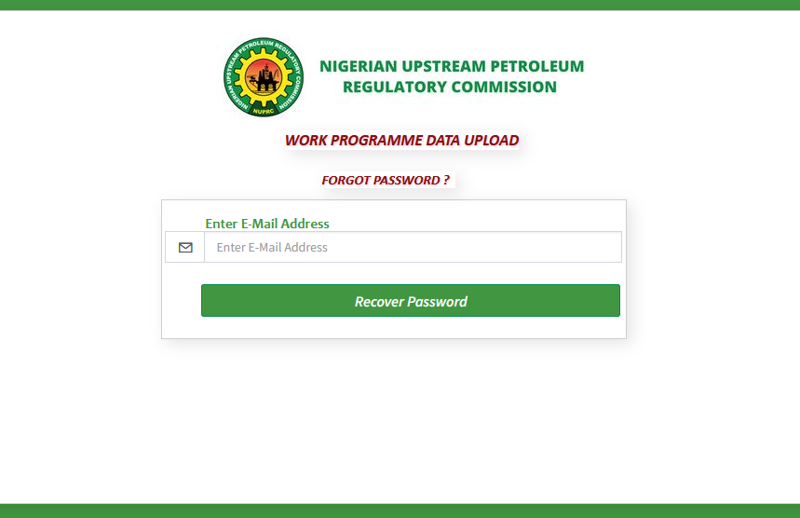

**Step C**

Click on the side menu on the left and click on Upload Presentation => Upload Power Point File

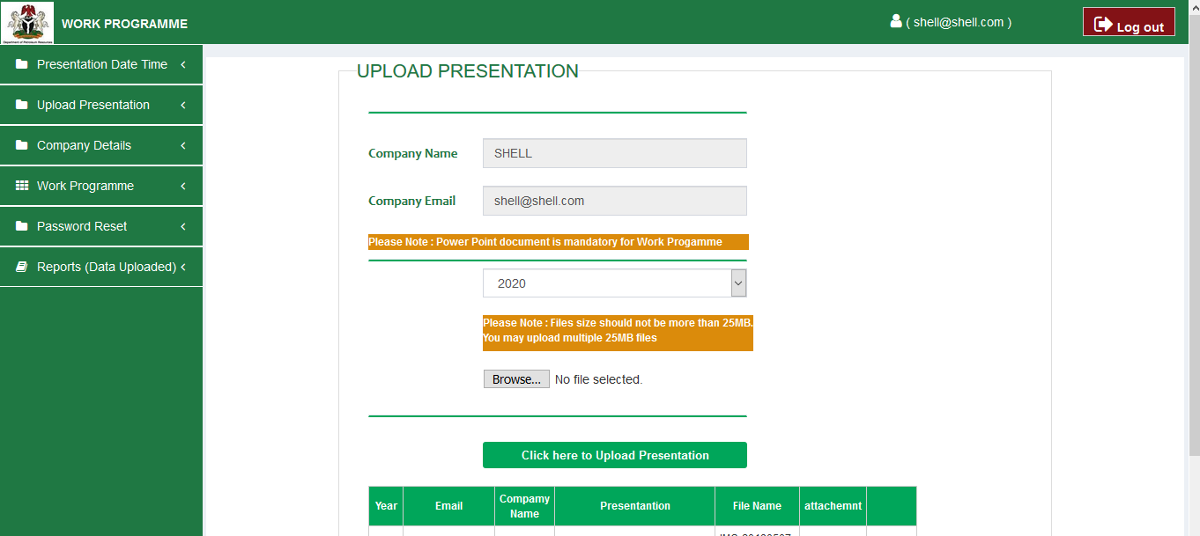

**Step D**

Click on the side menu on the left and click on Company Details => Input Company Details

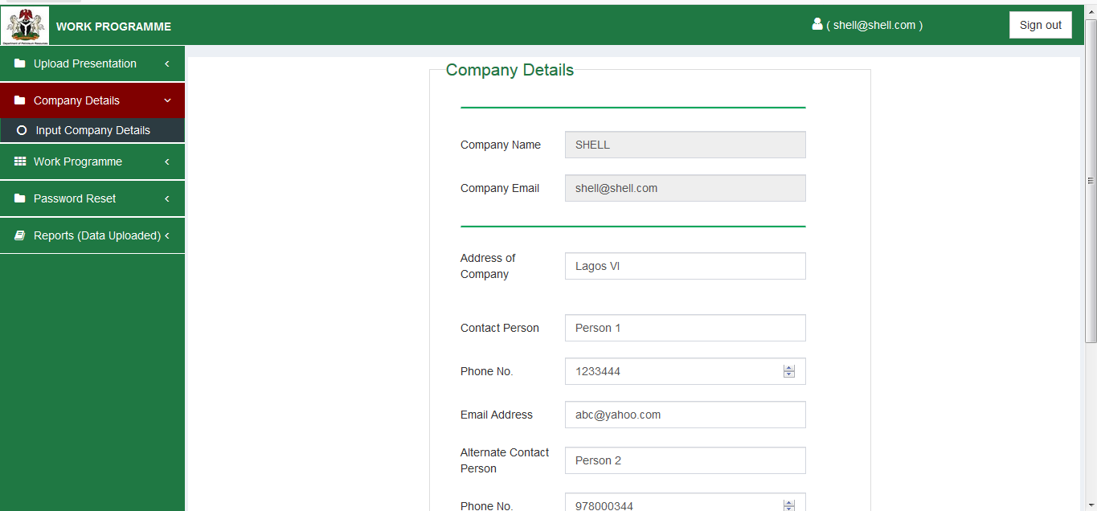

**Step E: Select date and time of presentation**

On the left side menu, click on Presentation Date Time => Select Date & Time

When date is selected it cannot be changed until DPR is contacted.

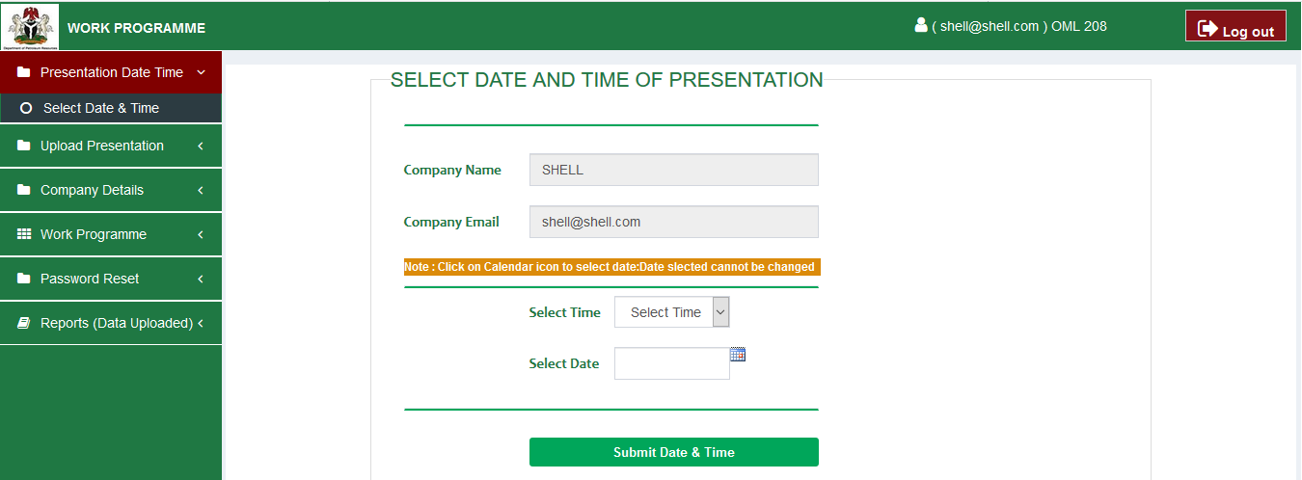

# **How to Fill Work Programme Forms Step By Step & Upload Attachments**

On the left side menu, click on Work Programme => Submit Work Programme

**Step 1**

**Concession Situation as at 1st January**

**Note:** It is only when “Year **of Work Programme”** is selected and “**Concession held”** is also selected then you can see data previously entered. – see below

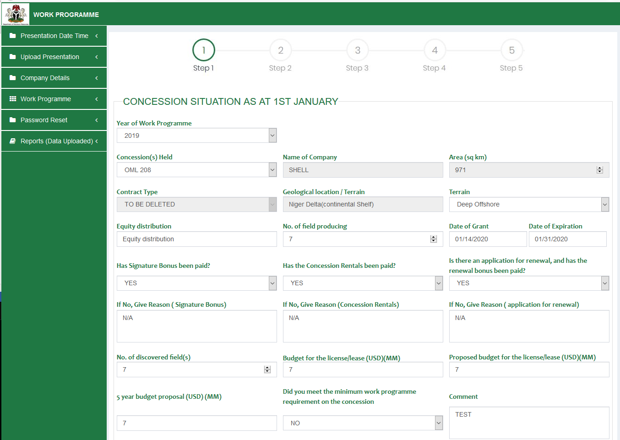

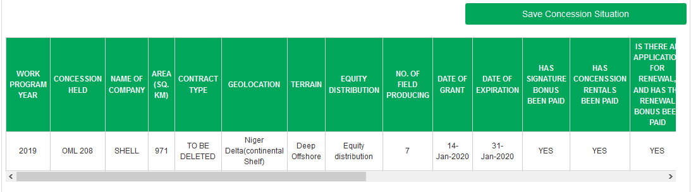

For Geophysical Activities On Quarterly Basis – Data must be provided On Quarterly Basis i.e. Quarter 1 , Quarter 2 , Quarter 3 , Quarter 4

**Acquisition**

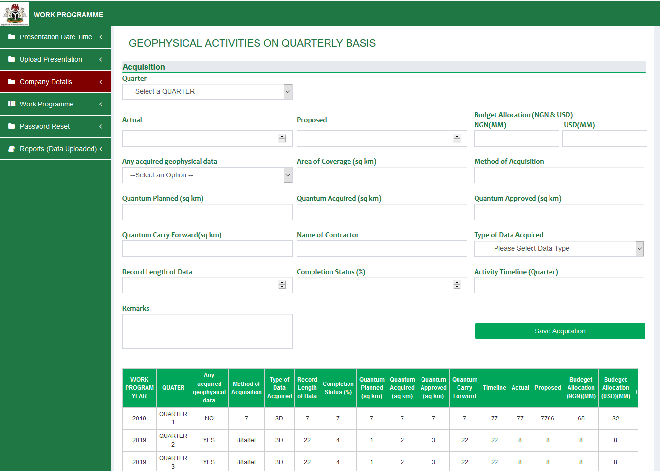

**For Processing**

Data must be provided On Quarterly Basis i.e. Quarter 1 , Quarter 2 , Quarter 3 , Quarter 4.

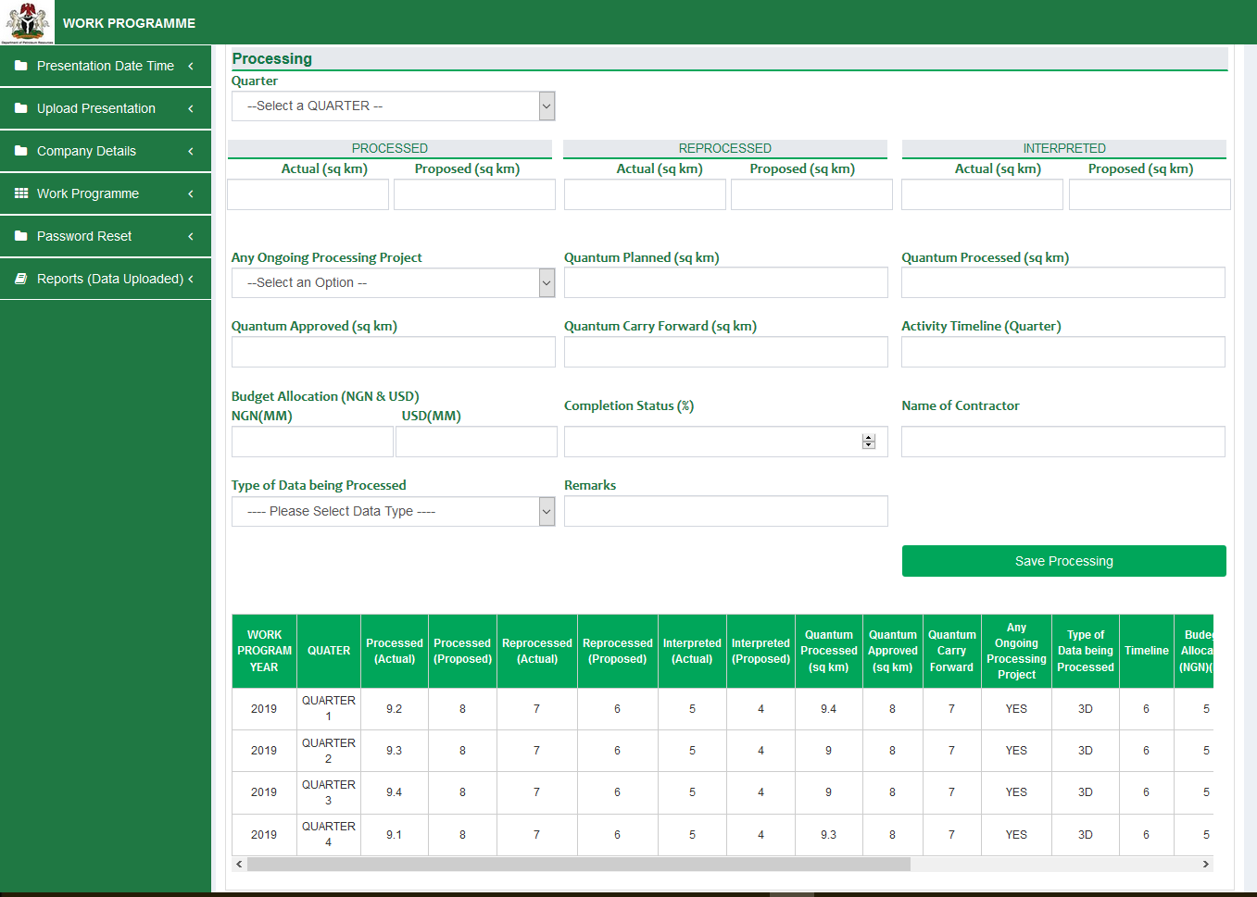

**For Drilling Operations**

Data must be provided On Quarterly Basis i.e. Quarter 1 , Quarter 2 , Quarter 3 , Quarter 4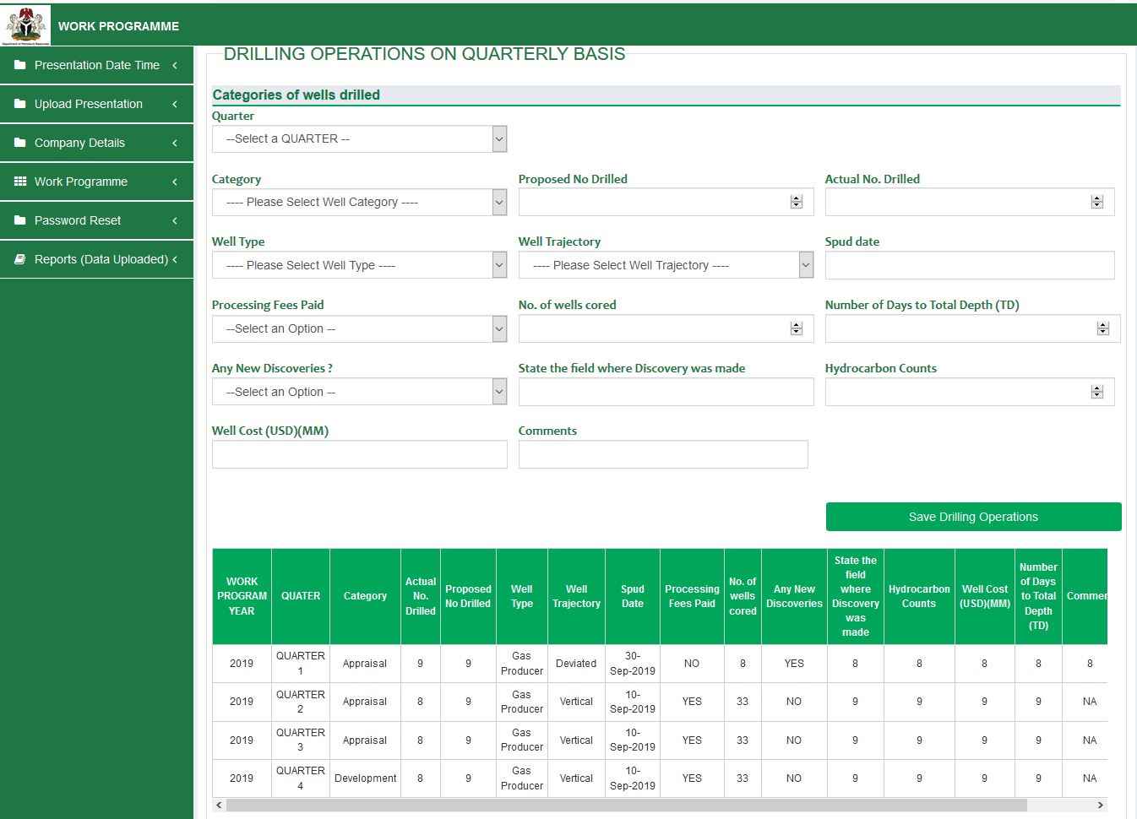

Click on “Save & Continue later “ or “ Save & Continue“



**Step 2**

**INITIAL WELL COMPLETION JOBS ON QUARTERLY BASIS**

Data must be provided On Quarterly Basis i.e. Quarter 1, Quarter 2, Quarter 3, Quarter 4

On Navigation to step 2 , the **concession name** is displayed beside the login email at the top right of the page as highlighted

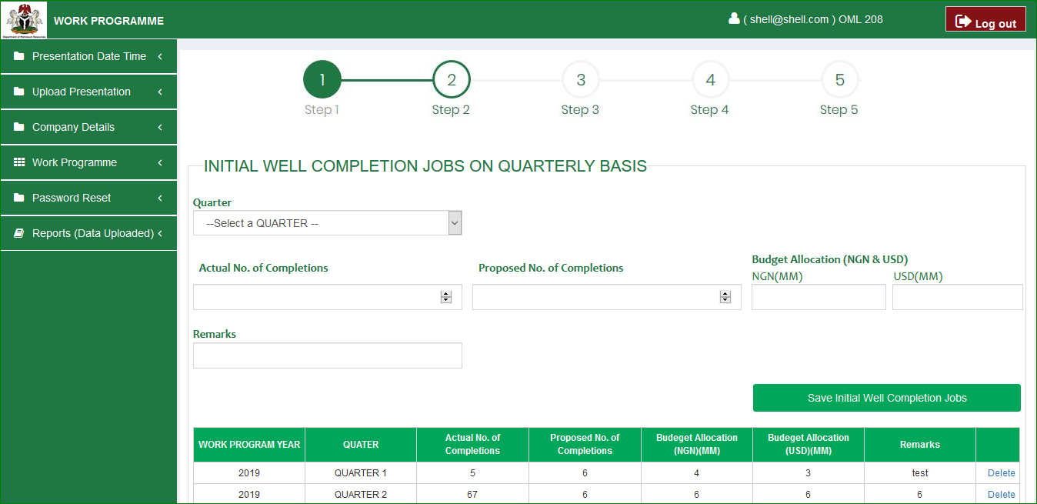

**WORKOVERS & RECOMPLETION JOBS ON QUARTERLY BASIS**

Data must be provided On Quarterly Basis i.e. Quarter 1, Quarter 2, Quarter 3, Quarter 4

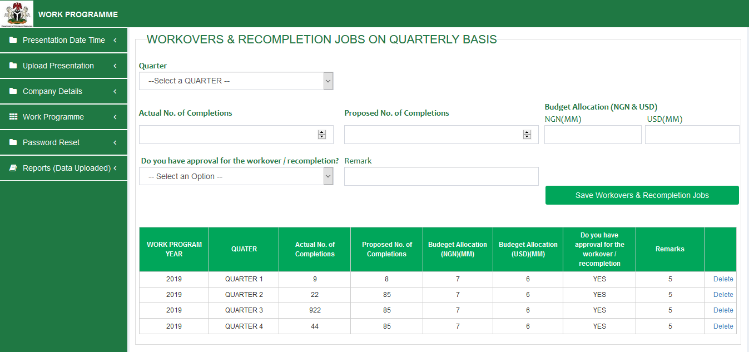

**FIELD DEVELOPMENT PLAN**

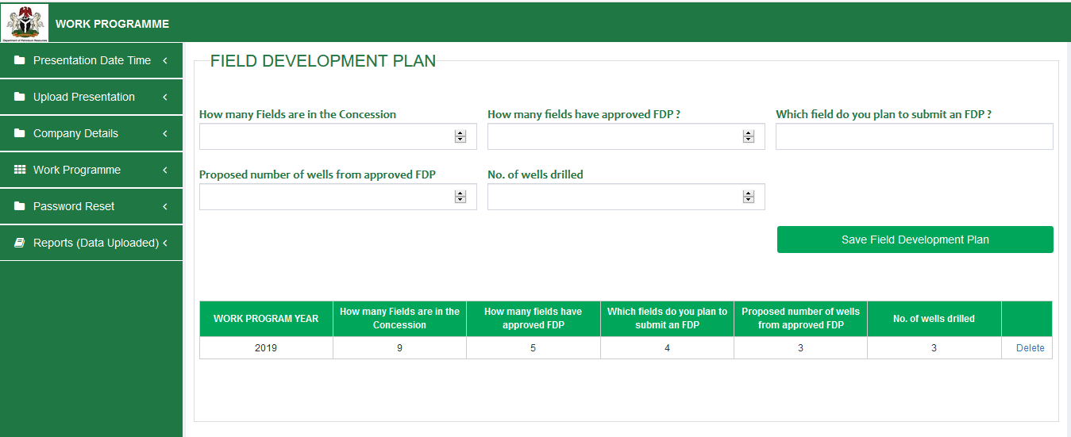

**OIL/CONDENSATE PRODUCTION ACTIVITIES**

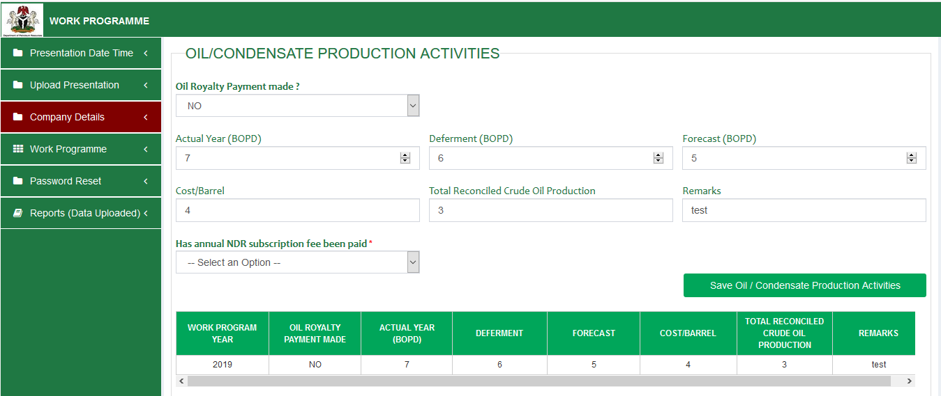

**ACTUAL YEAR MONTHLY PRODUCTION**

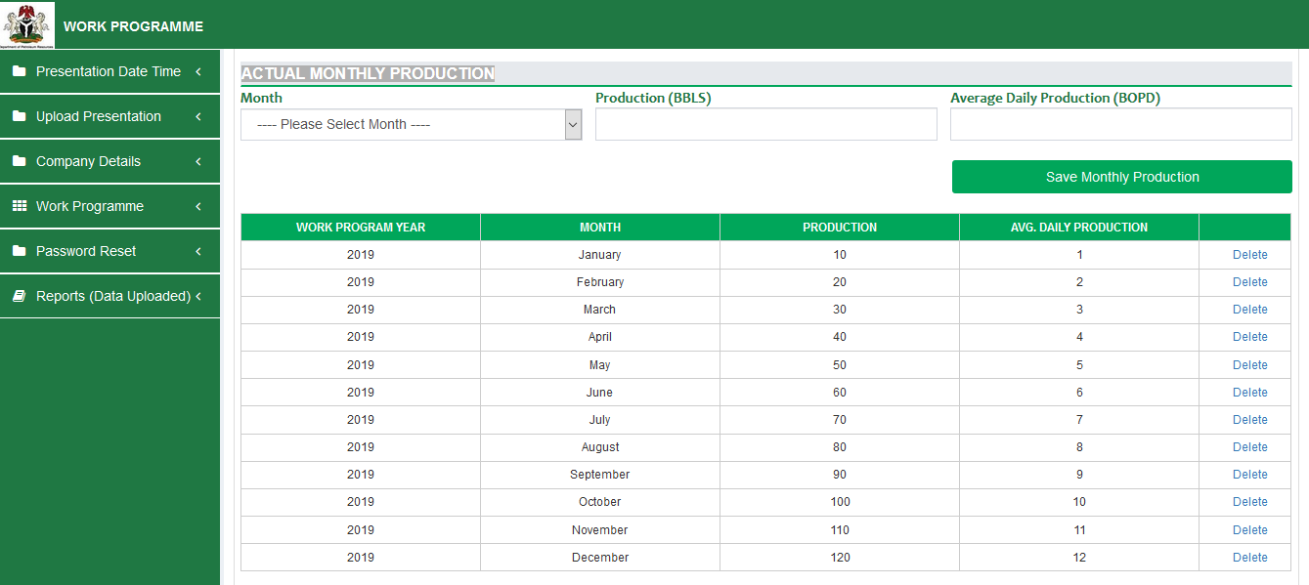

**PROPOSED YEAR MONTHLY PRODUCTION**

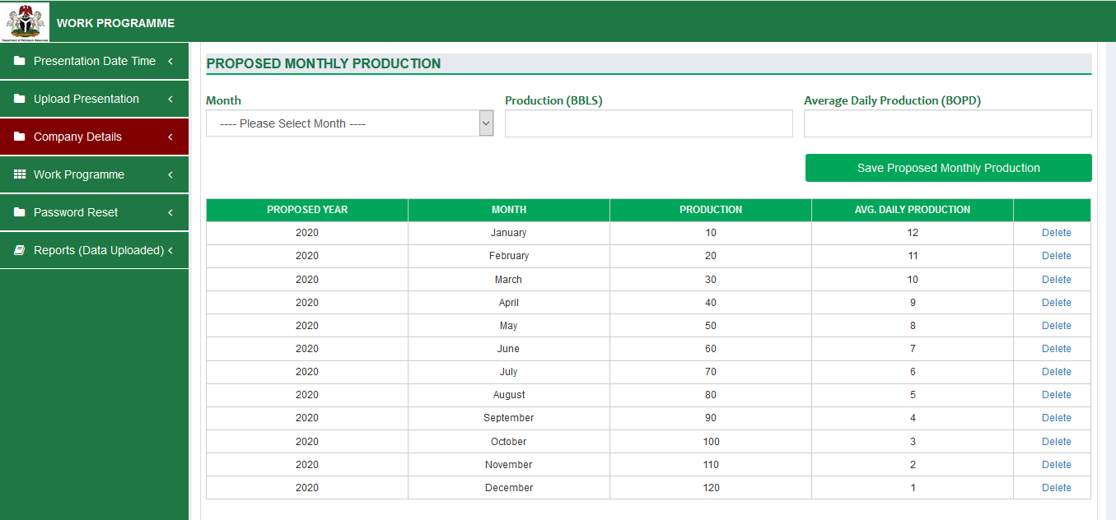

**Five Year Production Forecast: (Figures)**

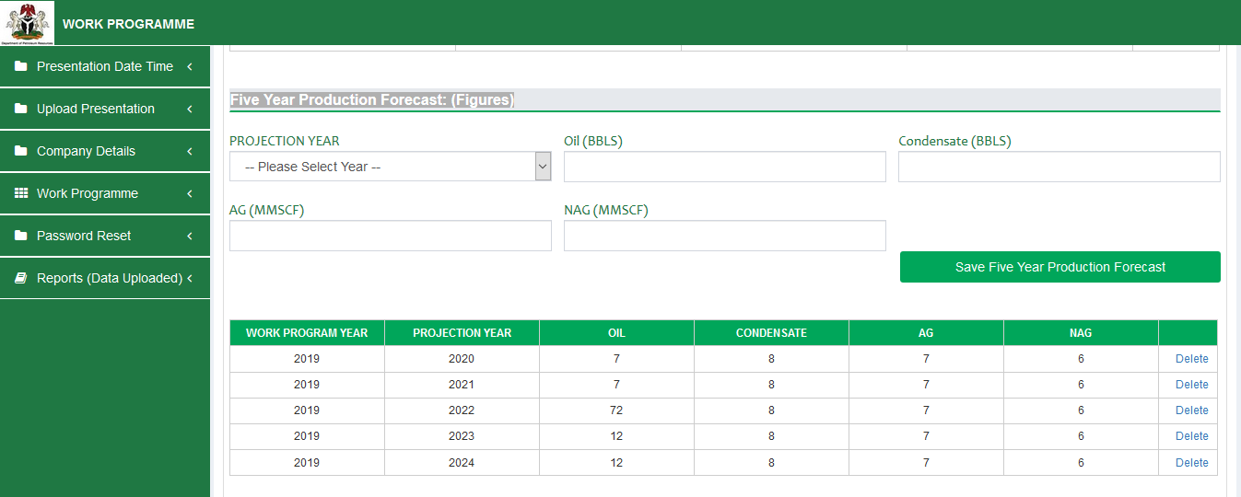

**Unitization**

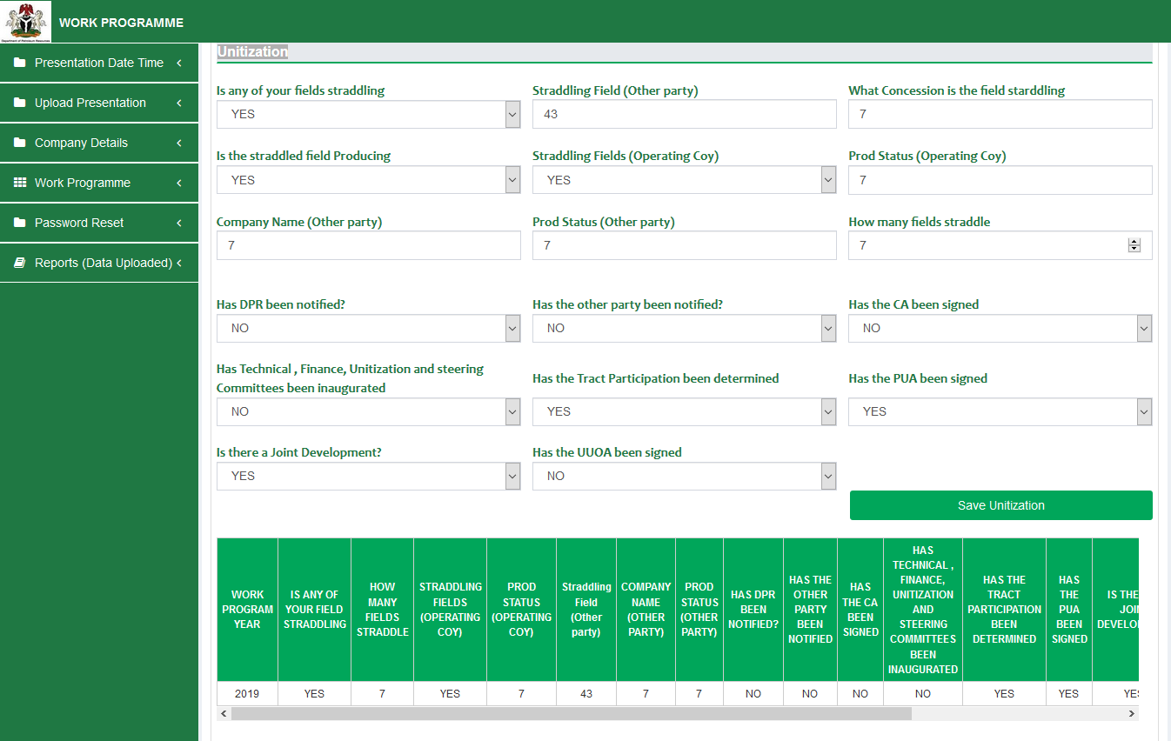

**GAS PRODUCTION ACTIVITIES**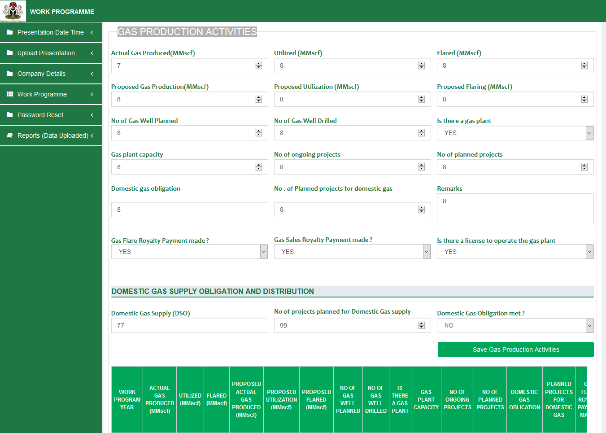

**RESERVES UPDATES (OIL & CONDENSATE) (MMBL)**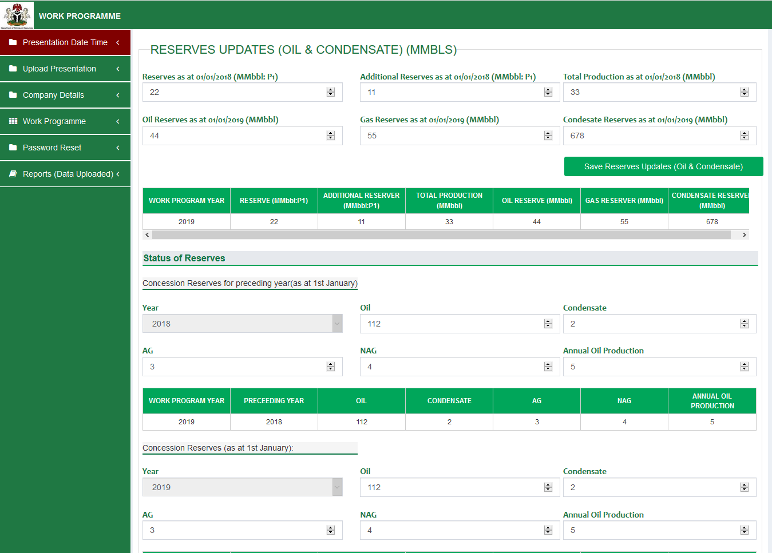

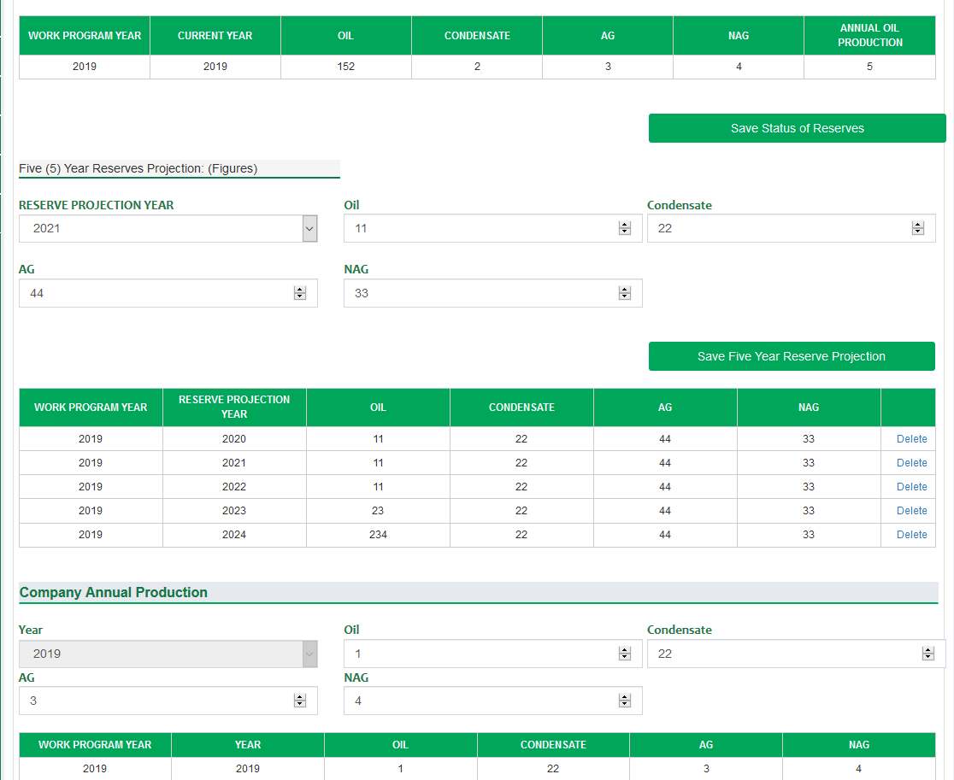

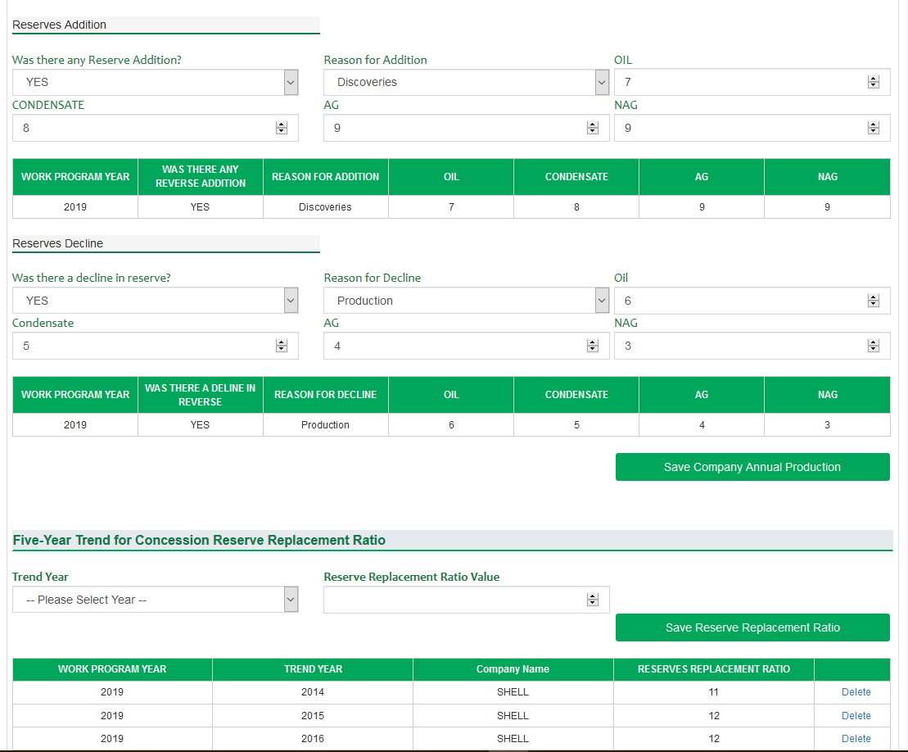



**Step 3** 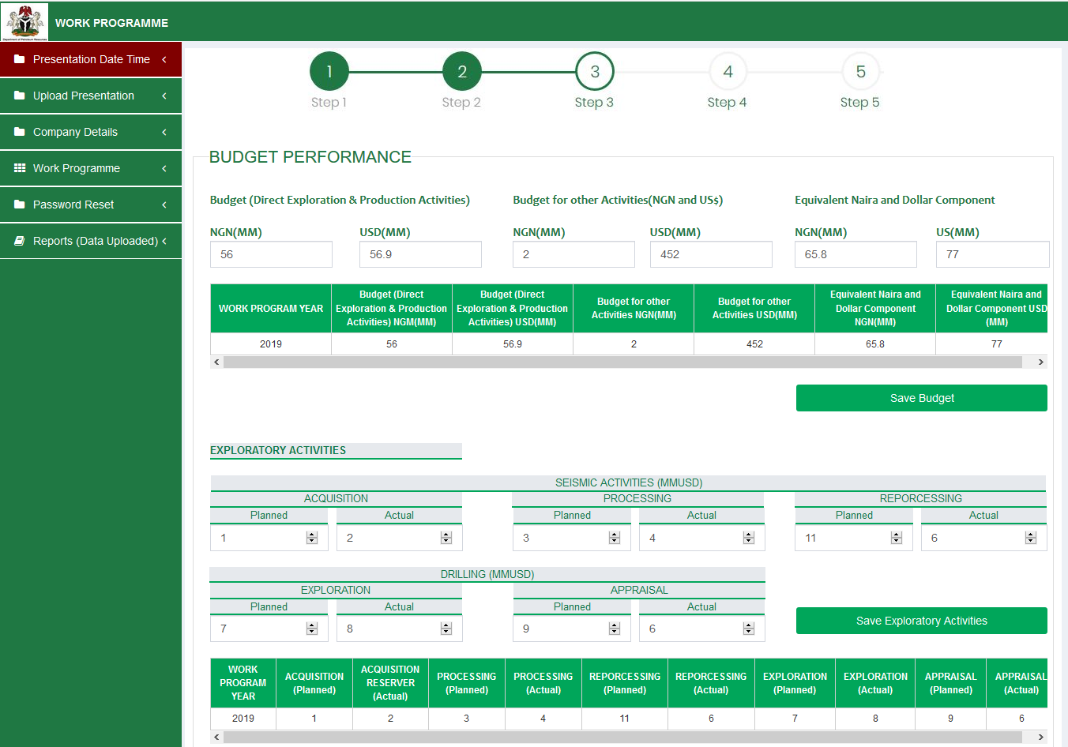

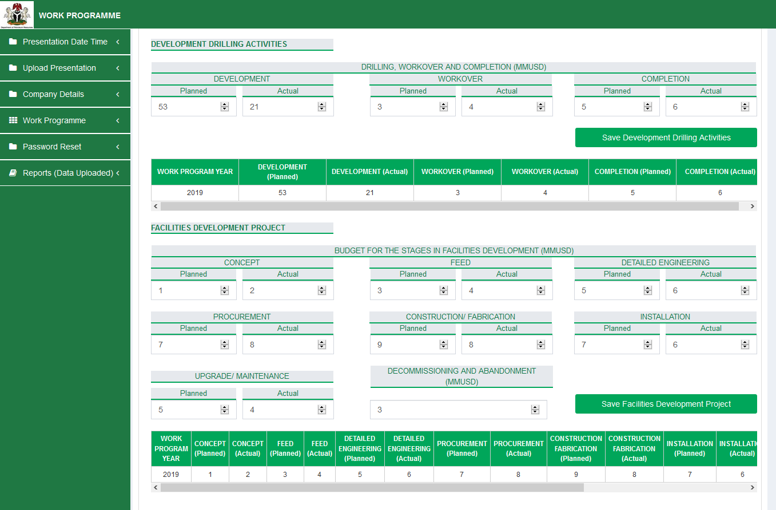

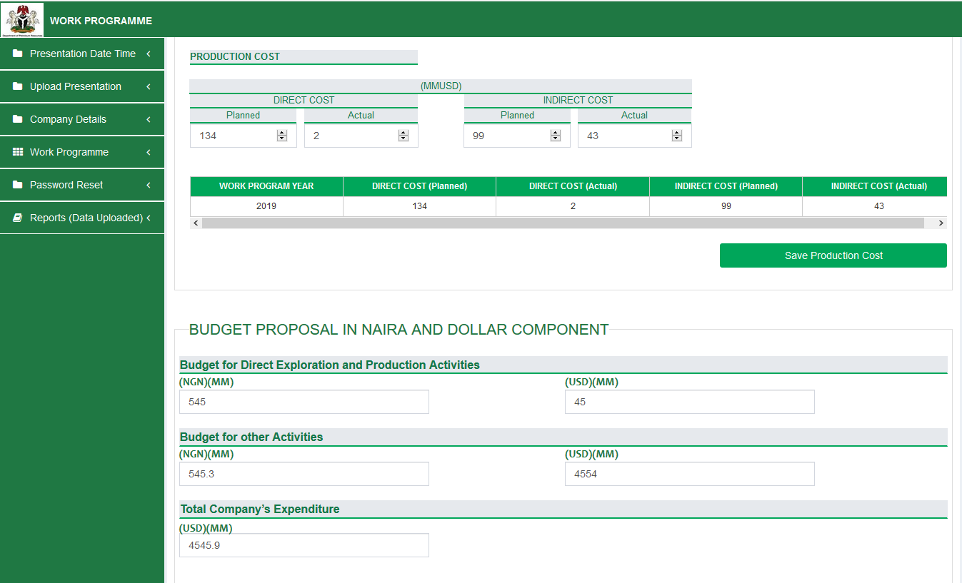

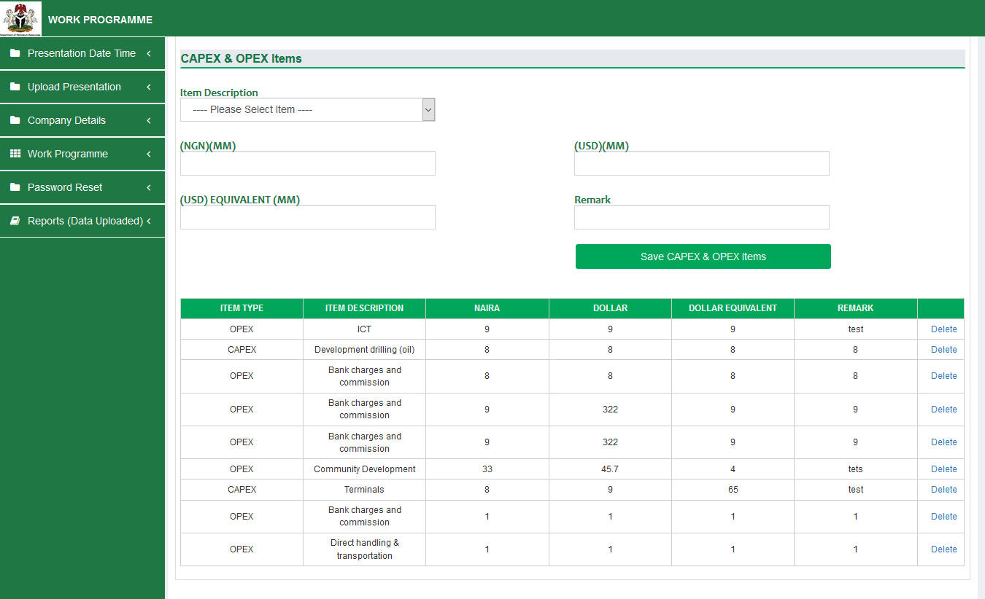

**Note: For Major projects and Upgrades as shown below,** Information for Actual & Proposed Year Must be provided. It means two records should be submitted. E&P companies are expected to provide information for Actual Year and click “Add Major Projects & Upgrades”, then provide information for Proposed Year and click “Add Major Projects & Upgrades”

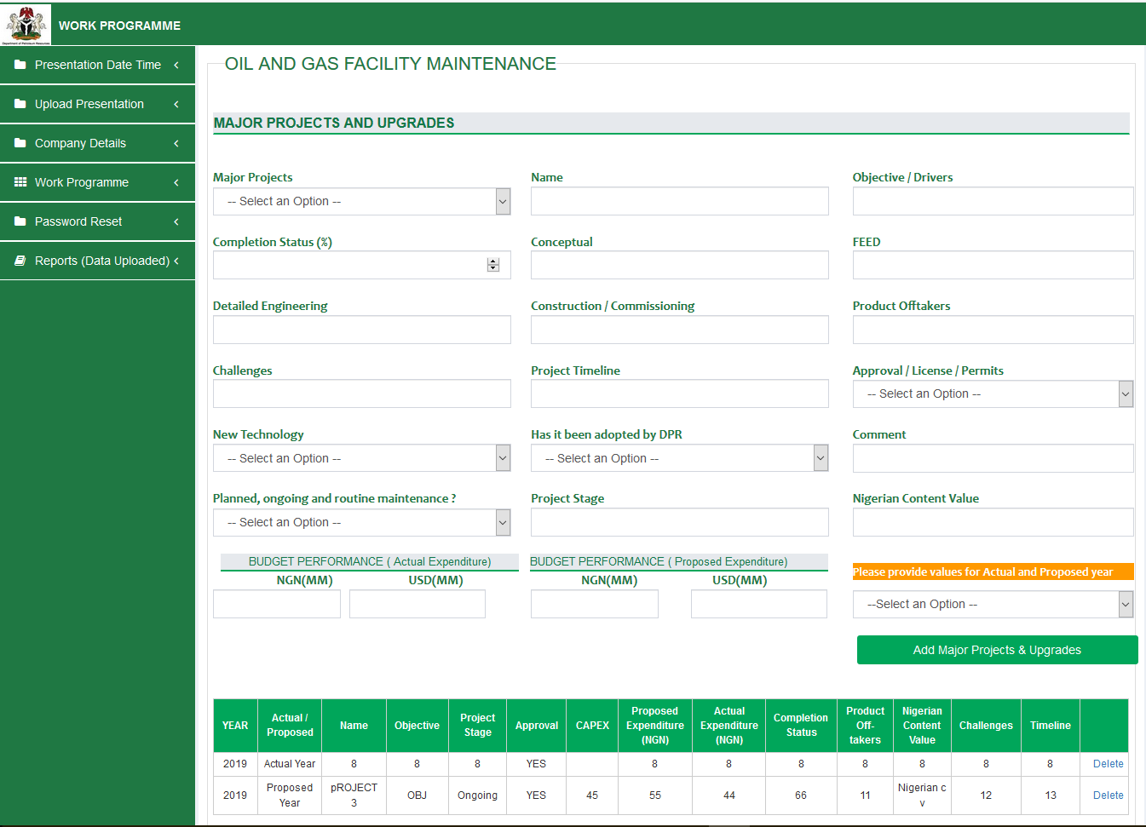

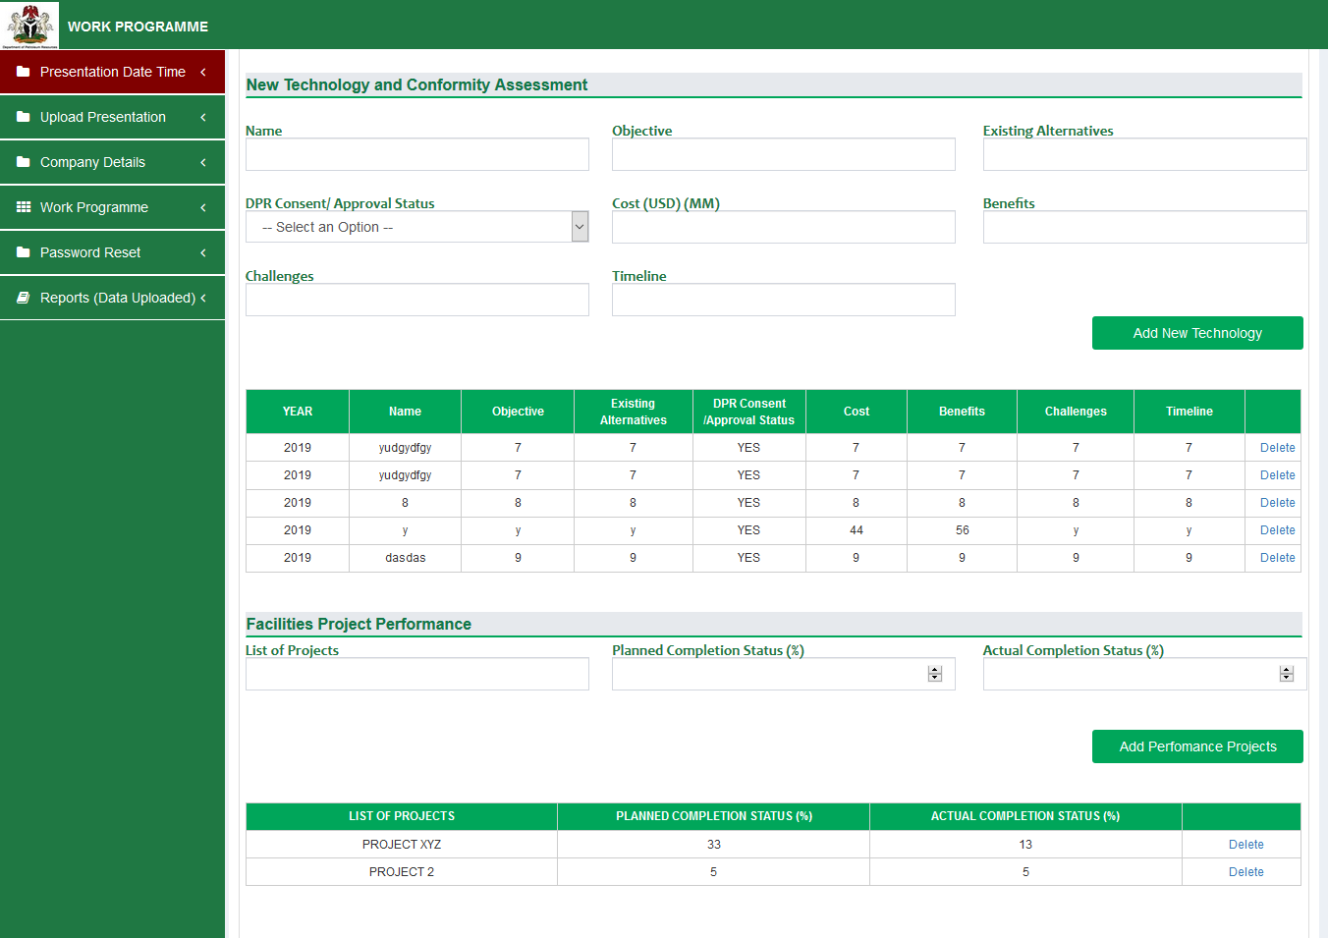



**Step 4**

**Note: For Staff Disposition – Training for Nigerians,** Information for Actual & Proposed Year must be provided. It means two records should be submitted. E&P companies are expected to provide information for Actual Year and click “Add Staff Disposition”, then provide information for Proposed Year and click “Add Staff Disposition”

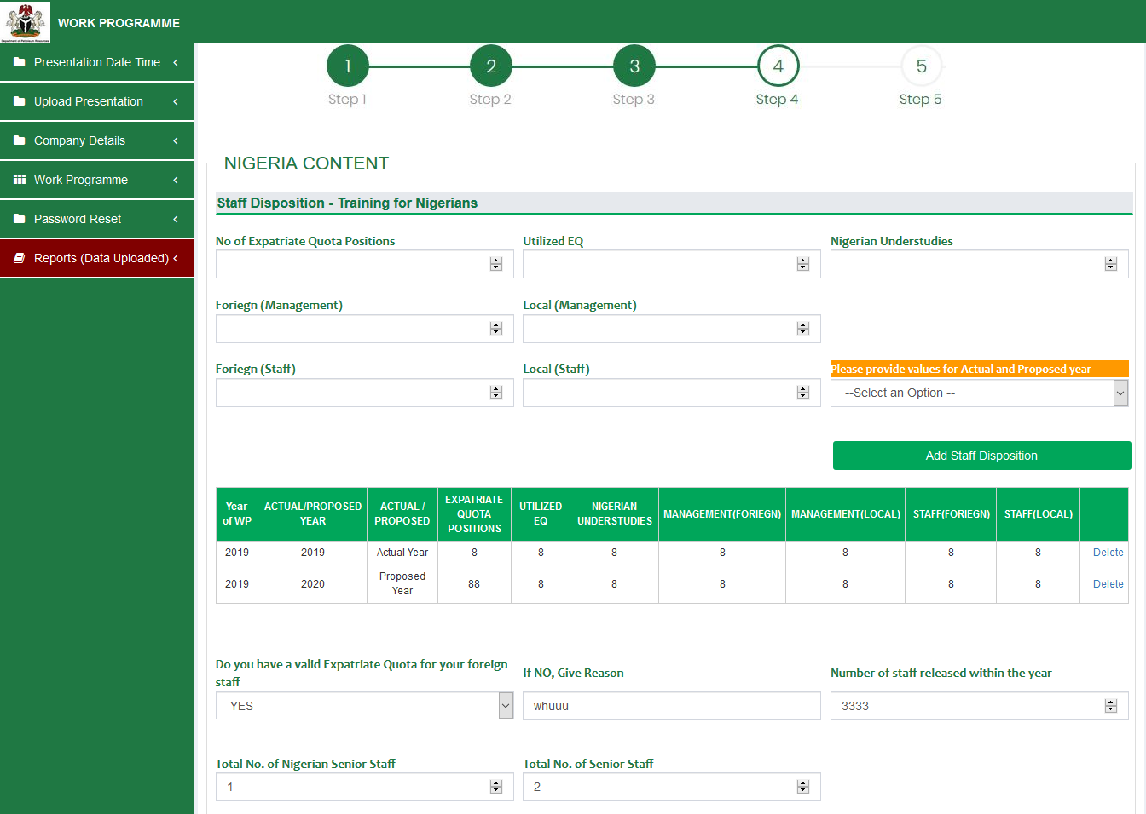

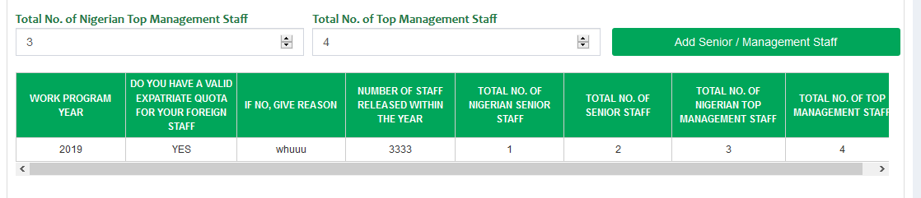

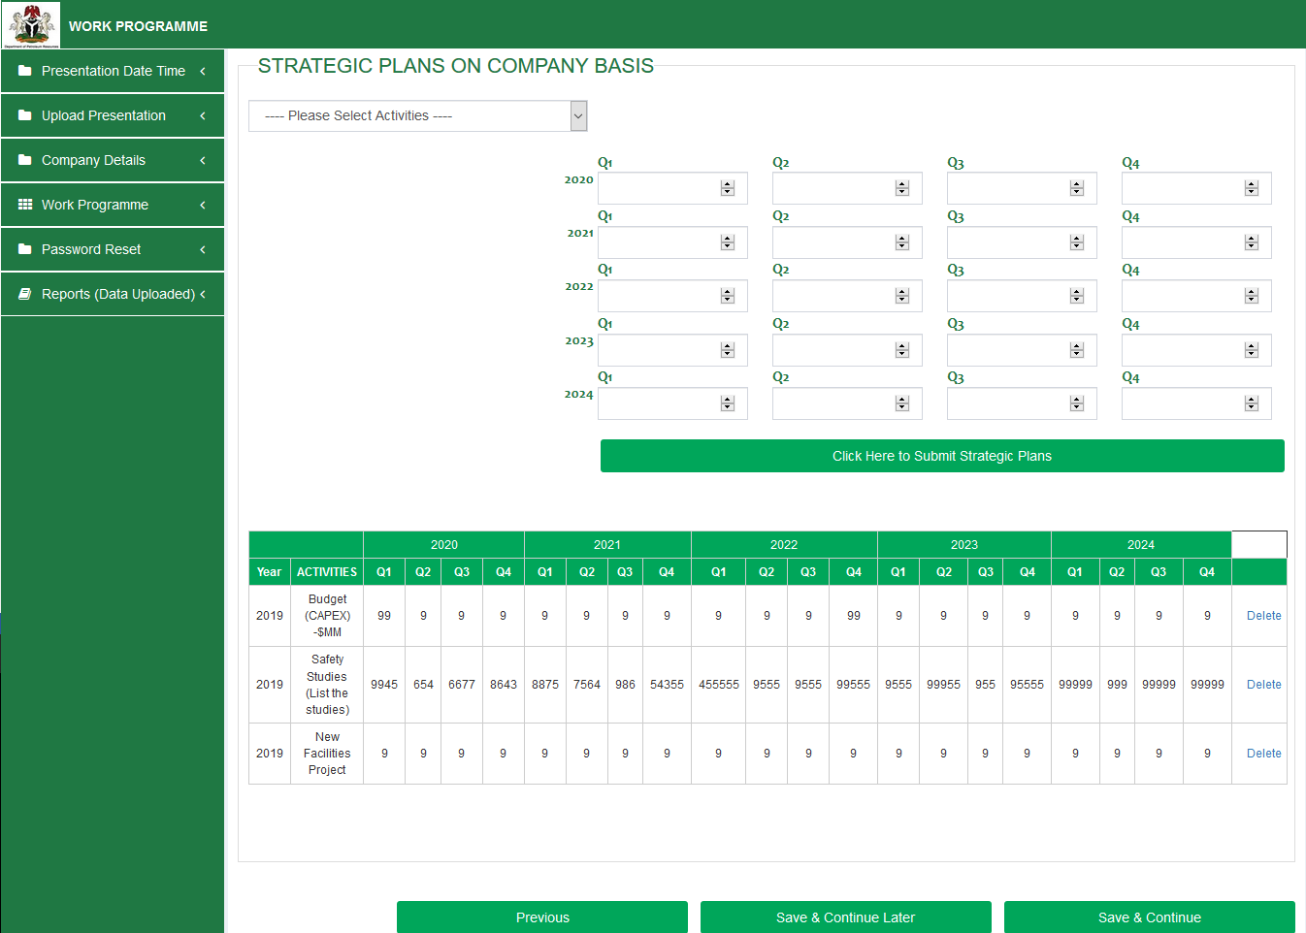

**Step 5**

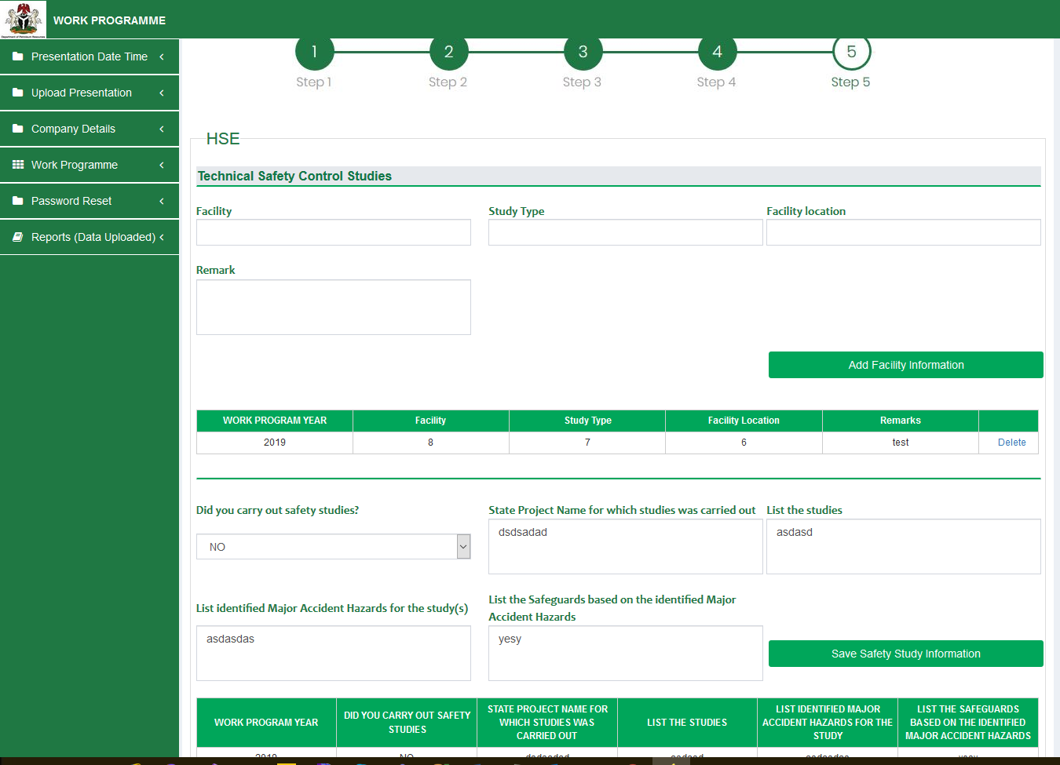

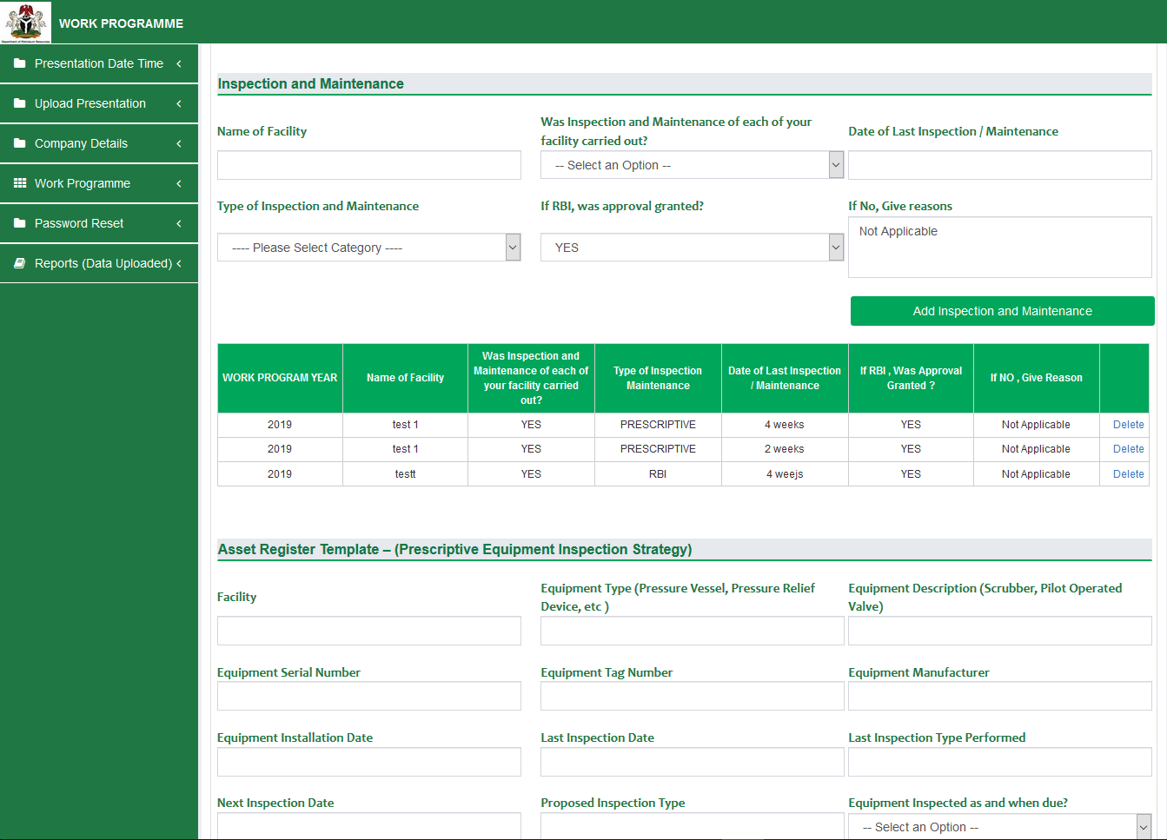

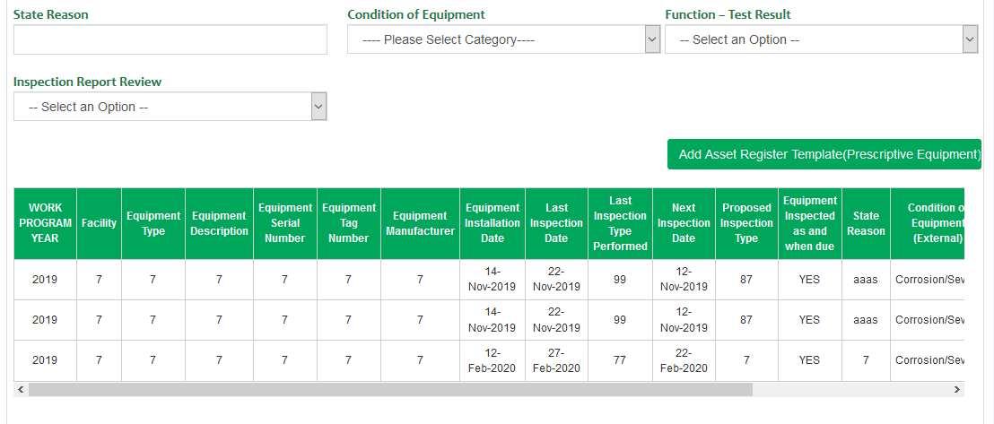

**Asset Register Template – (RBI Equipment Inspection Strategy)**

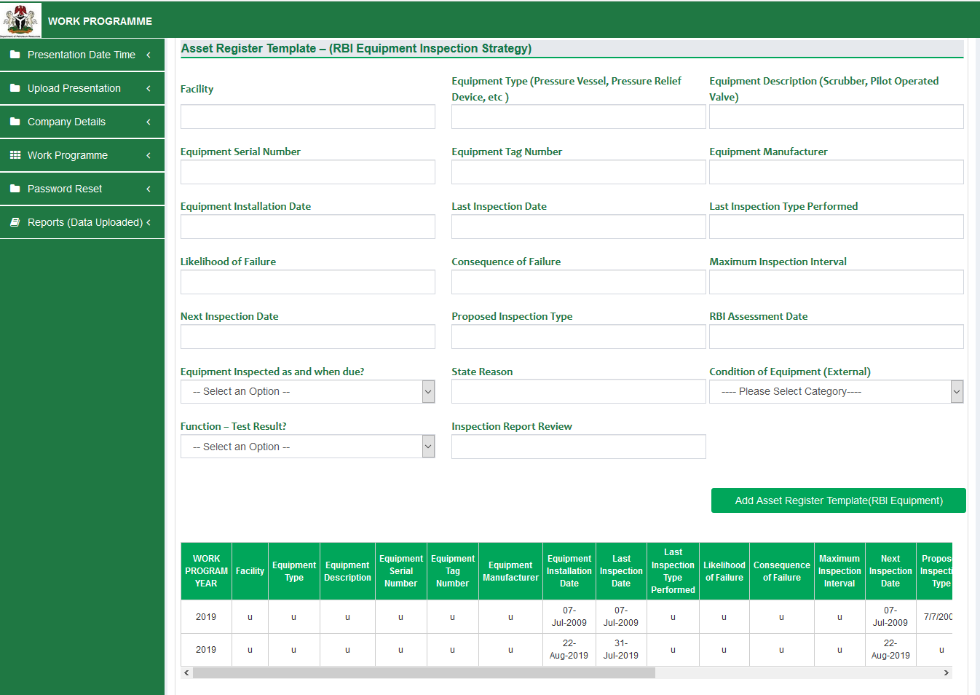

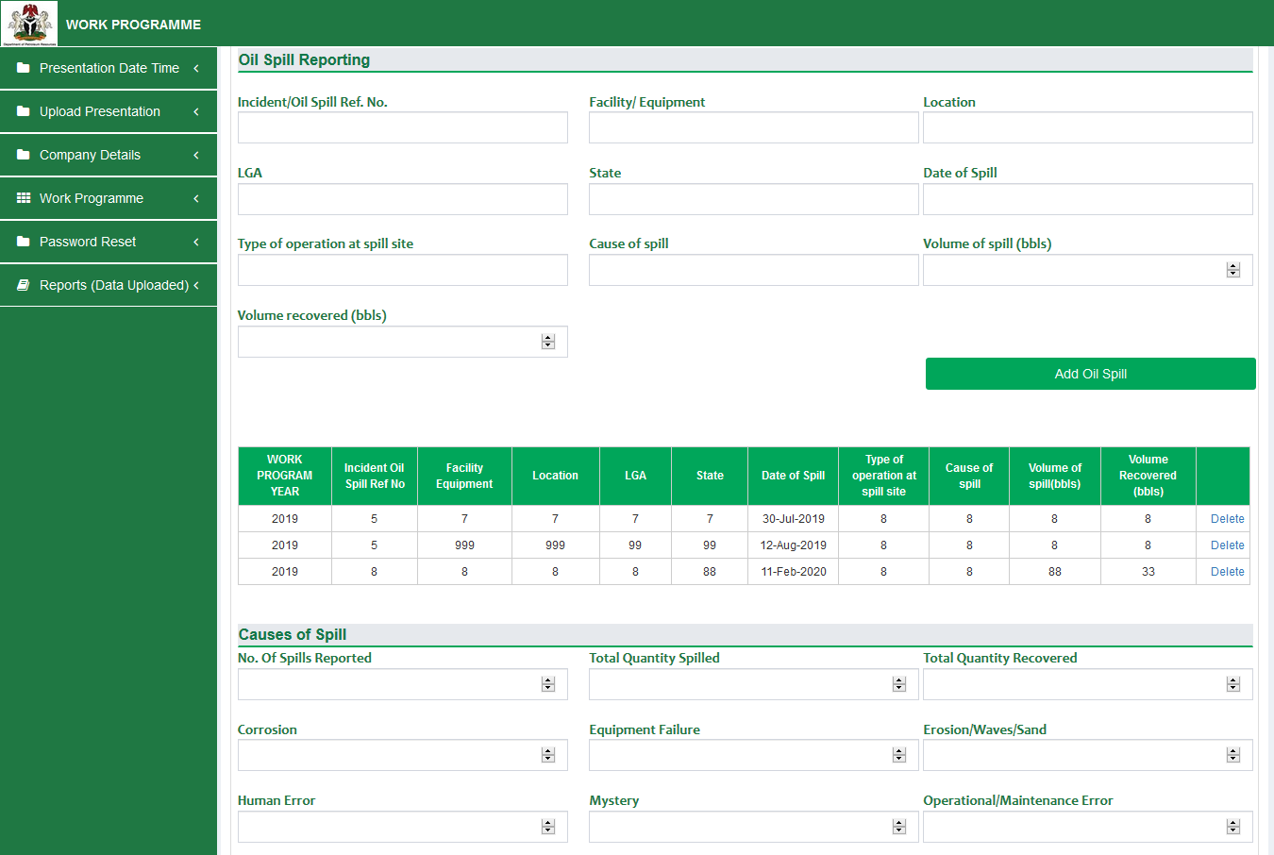

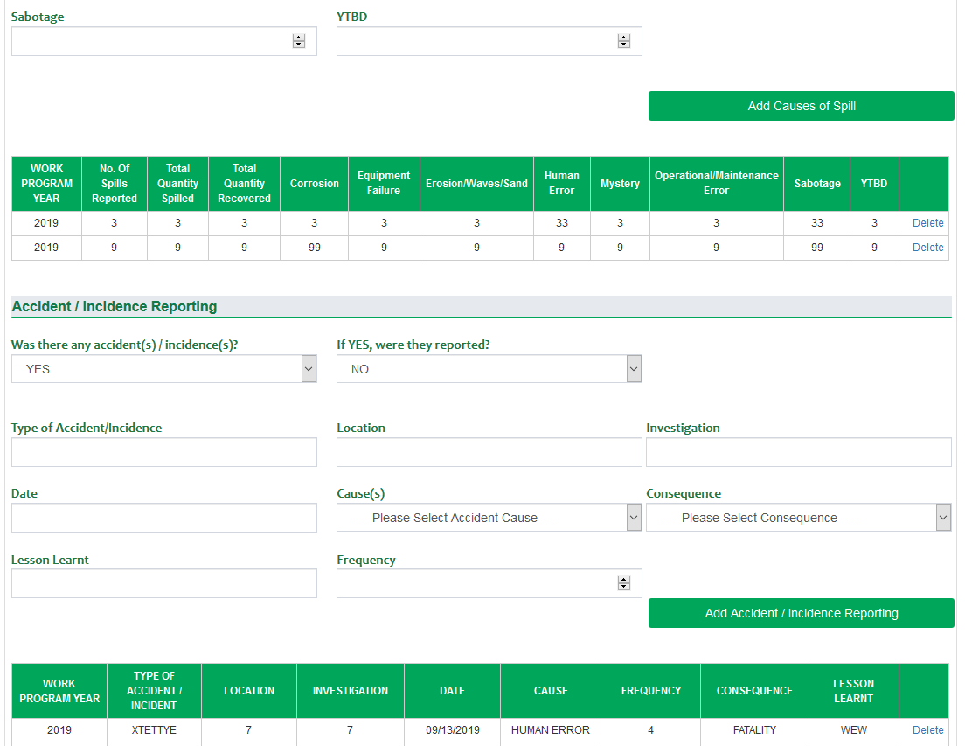

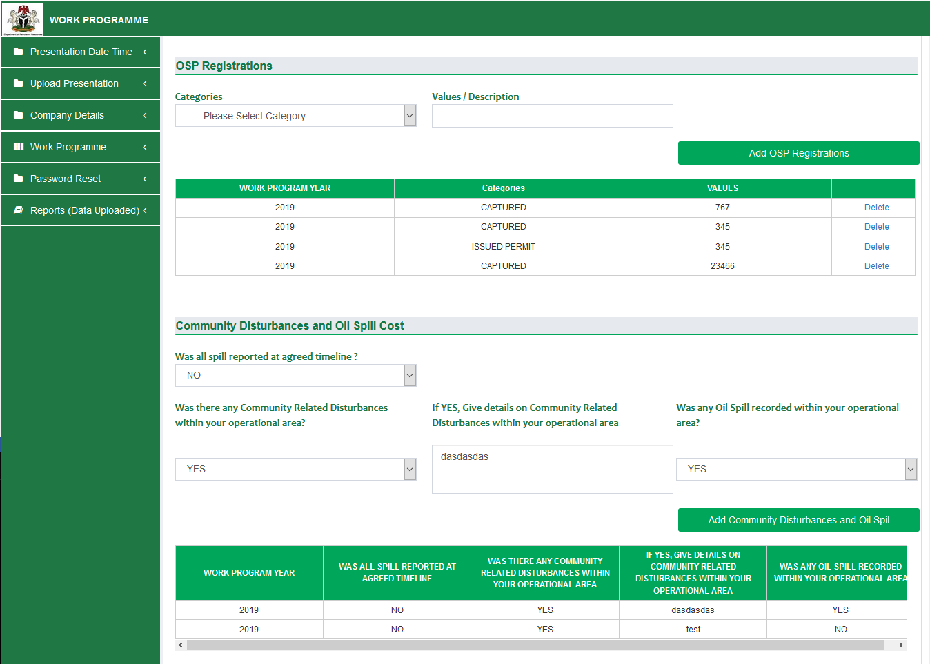

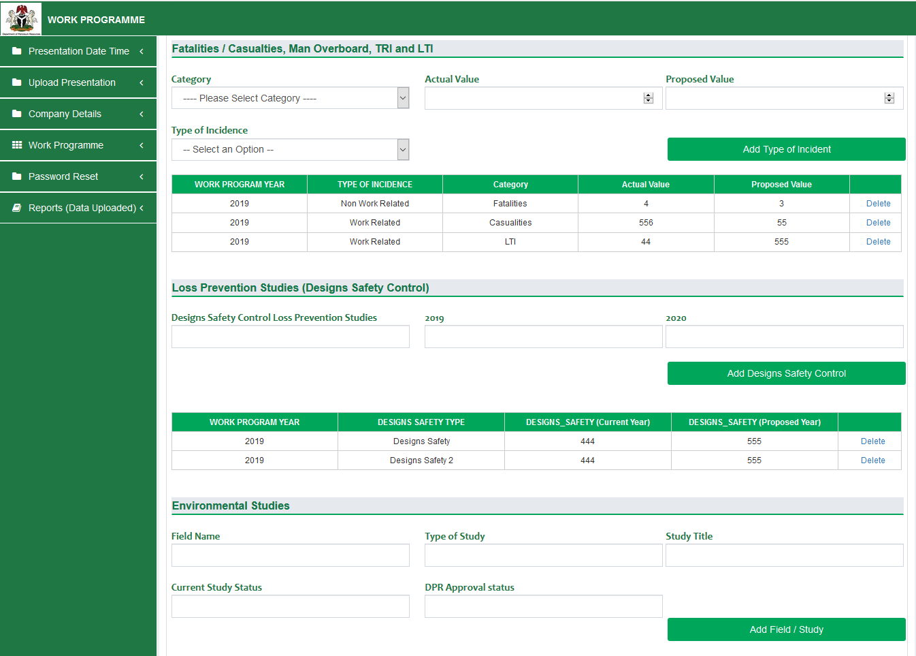

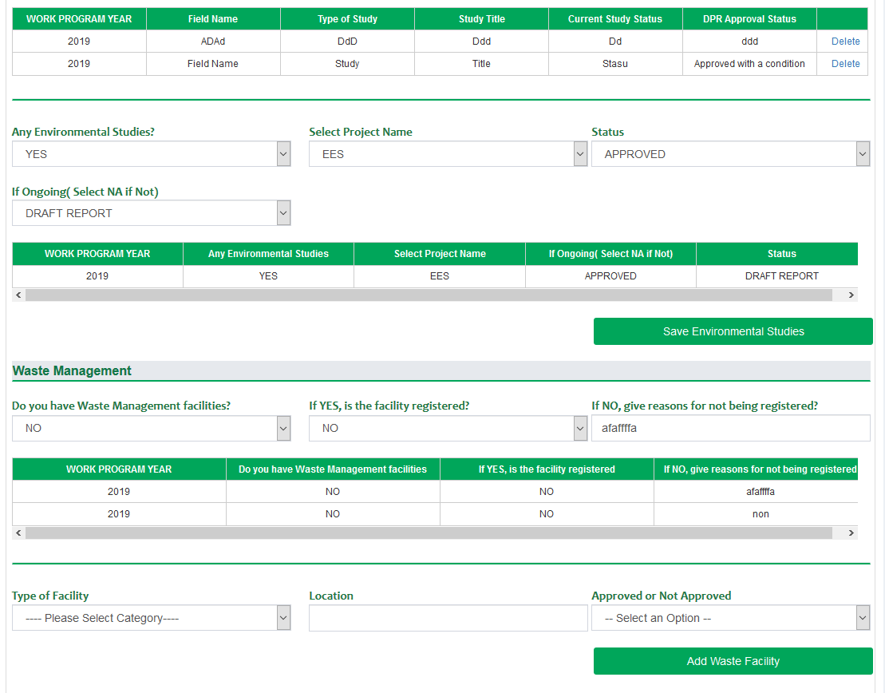

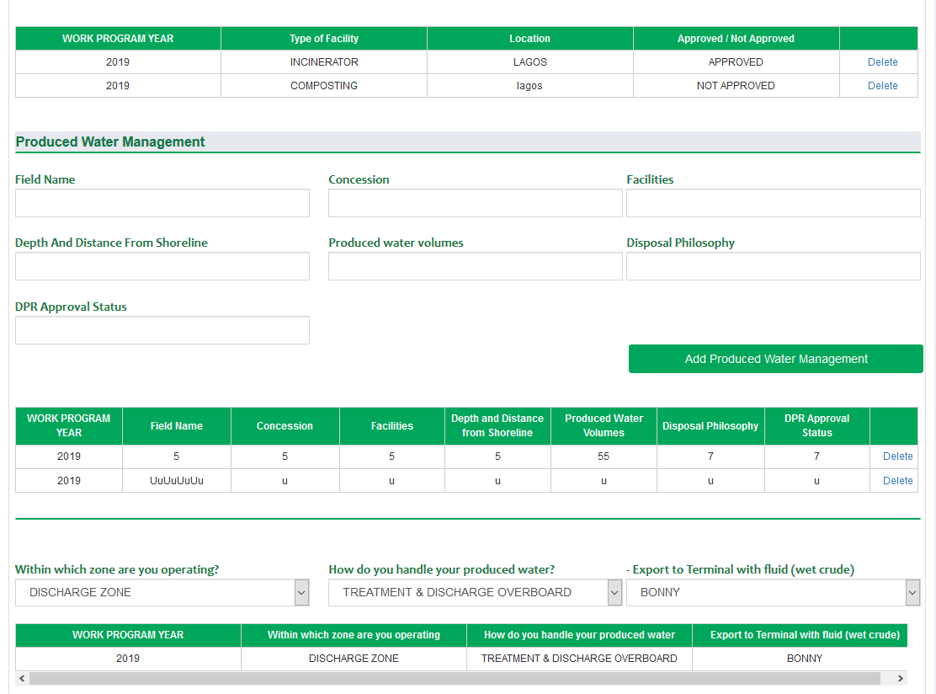

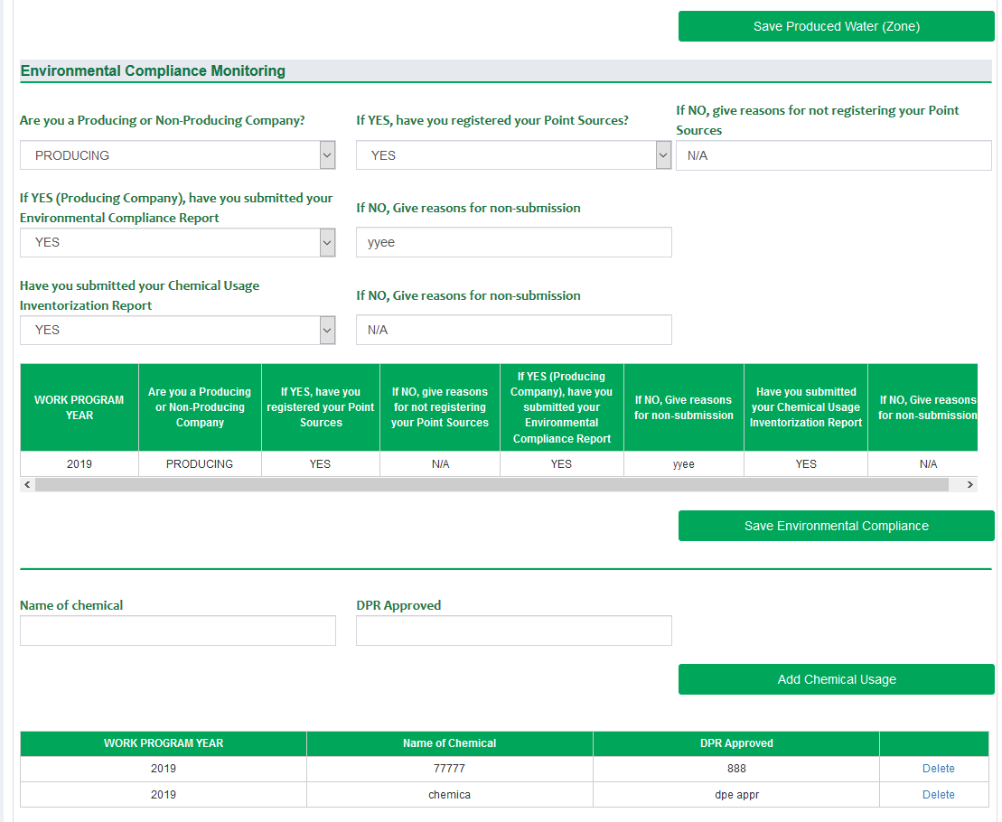

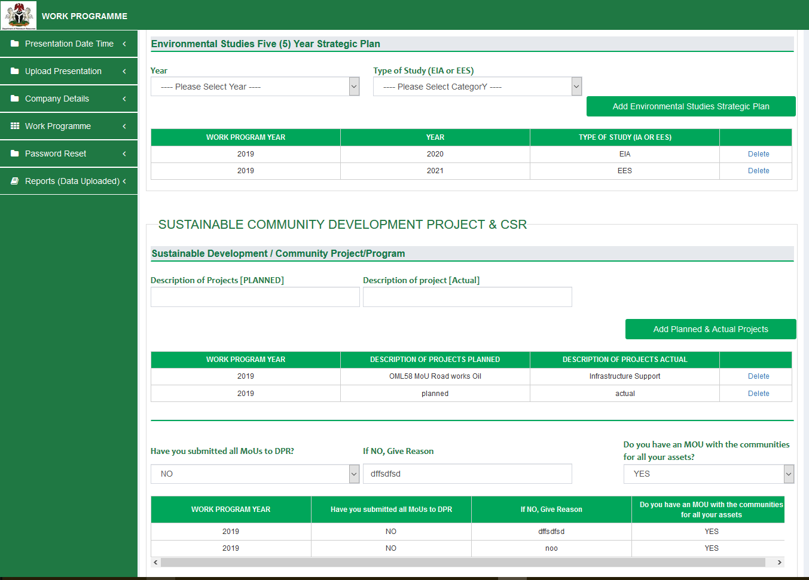

**Note: For Capital Projects / Scholarship**, Information for Actual & Proposed Year must be provided. It means two records should be submitted. E&P companies are expected to provide information for Actual Year and click “Add Capital Projects” / “Add Scholarship”, then provide information for Proposed Year and click “Add Capital Projects” / “Add Scholarship”

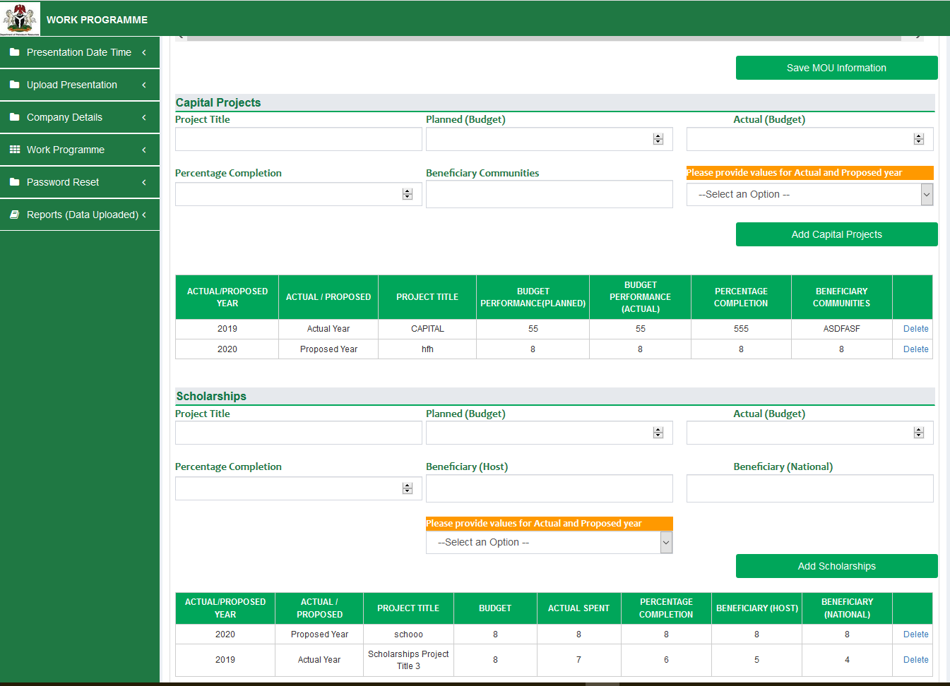

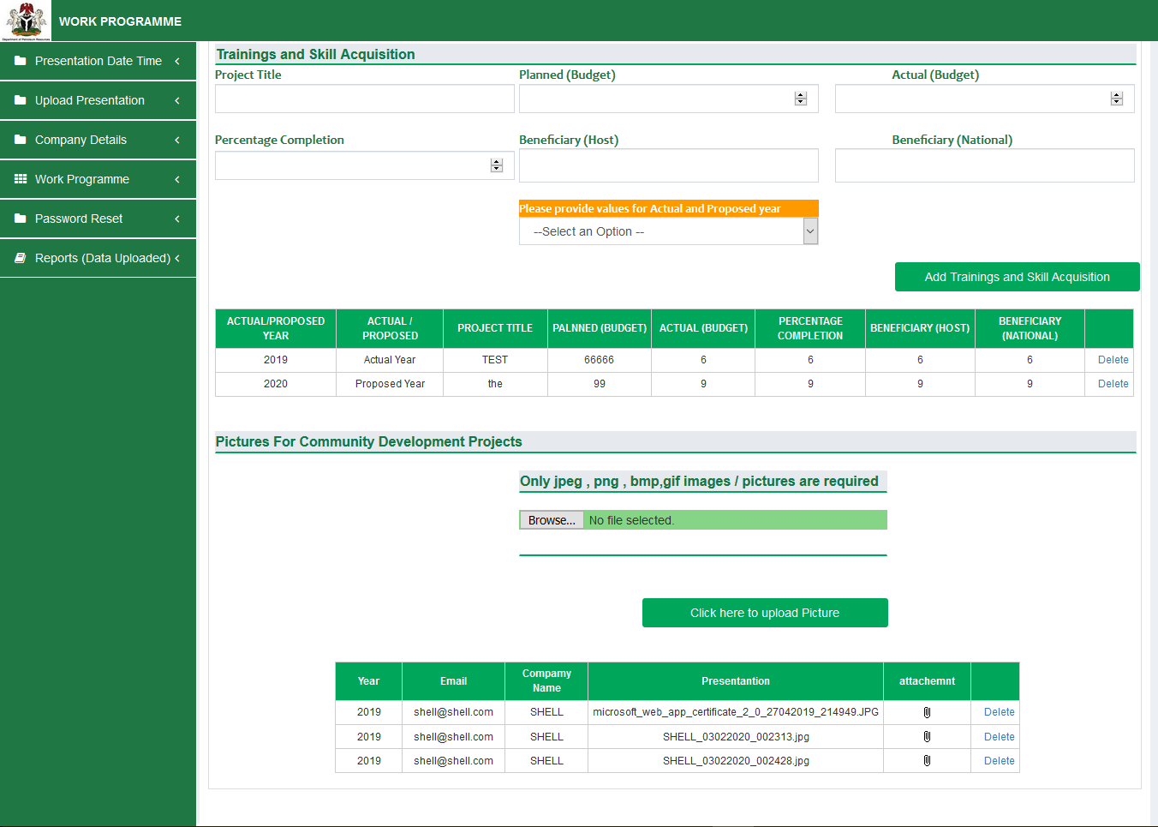



An Email Notification would be sent to your email address upon completion for each Concession.

**Appendix A: Terms, Definitions and Acronyms**

| Term | Description |
| --- | --- |
| SQ KM | Square Kilometre |
| USD | United States Dollar |
| MM | Million |
| NGN | Naira |
| BOPD | Barrels of oil per day |
| BBLS | barrel (bbl) |
| MMSCF | million standard cubic feet, a common measure for volume of gas |